**Assignment module 2 : Installation and Maintenance of Hardware and Its**

**Section 1: Multiple Choice**

1. Which of the following precautions should be taken before working on computer hardware?

a) Ensure the computer is plugged in to prevent electrostatic discharge.

b) Wear an anti-static wrist strap to prevent damage from electrostatic discharge.

c) Work on carpeted surfaces to prevent slipping.

d) Use magnetic tools to handle components more easily.

ANS. Wear anti-static wrist strap to prevent damage from electrostatic discharge.

2 . What is the purpose of thermal paste during CPU installation?

a) To insulate the CPU from heat.

b) To provide mechanical support for the CPU.

c) To improve thermal conductivity between the CPU and the heat sink.

d) To prevent the CPU from overheating.

Ans: To improve thermal conductivity between the CPU and the heat sink.

3 . Which tool is used to measure the output voltage of a power supply unit (PSU)?

a) Multimeter

b) Screwdriver

c) Pliers

d) Hex key

Ans : Multimeter

4 . Which component is responsible for storing BIOS settings, such as date and time, even when the computer is powered off?

a) CMOS battery

b) CPU

c) RAM

d) Hard drive

Ans: CMOS battery

**Section 2 :- True or False**

5 . True or False: When installing a new hard drive, it is essential to format it before use.

Ans: True

6 . True or False: A POST (Power-On Self-Test) error indicates a problem with the CPU.

Ans : False

7 . True or False: It is safe to remove a USB flash drive from a computer without ejecting it first.

Ans : False

**Section 3: Short Answer**

8. Describe the steps involved in installing a new graphics card in a desktop computer.

ANS. Answer : Steps in installing a new graphics card in a desktop computer:

* Power off the computer and unplug it.
* Open the computer case.
* Locate the PCIe x16 slot on the motherboard.
* Remove the slot cover from the case.
* Insert the graphics card into the PCIe slot firmly.
* Secure the card with a screw or latch.
* Connect any required power cables from the power supply.
* Close the case, reconnect cables, and power on.
* Install or update the graphics card drivers.

9. What is RAID, and what are some common RAID configurations?

ANS. RAID (Redundant Array of Independent Disks) is a data storage technology that combines multiple physical disk drives into a single logical unit to improve performance, data redundancy, and fault tolerance.

Common RAID configurations :

1. RAID 0 : Data is split into blocks and distributed across multiple drives.

2. RAID 1: ( Mirroring ): Data is duplicated on two drivers - high reliability, but storage capacity is haled.

3. RAID 5 : Data and parity information are striped across three or more drives.

4. RAID 6 (Striping with Double Parity):-- Similar to RAID 5, but with additional parity information, allowing for two drive failures.

5.RAID 10 (1+0):-- Combines RAID 1 and RAID 0; data is mirrored and then striped.

**Section 4: Practical Application**

10. Demonstrate how to replace a CPU fan in a desktop computer.

Ans:

1.Open the Computer Case

2.Locate and Disconnect the CPU Fan

3.Remove the Old CPU Fan

4.Clean off Old Thermal Paste

5.Apply New Thermal Paste

6.Install the New CPU Fan and Heatsink

7.Reconnect the Fan Cable

8.Close the Case and Test

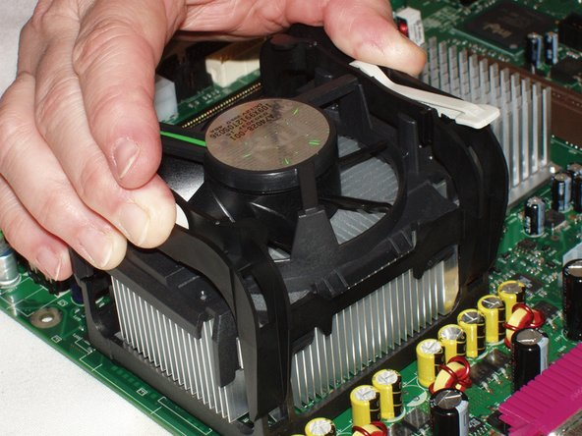

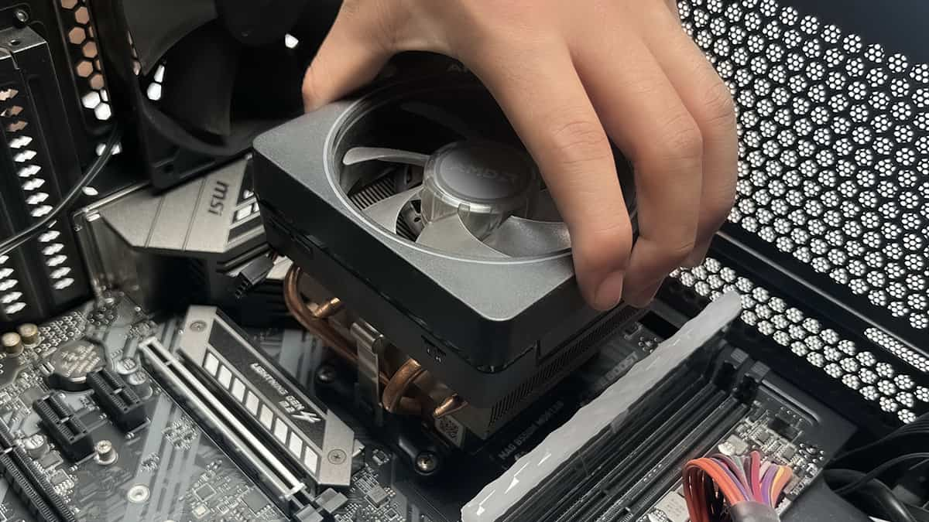

**Section 5: Essay**

11. Discuss the importance of regular maintenance for computer hardware and provide examples of maintenance tasks.

### Ans.

### Why Regular Maintenance Matters-

can cause overheating and damage sensitive components such as the CPU, GPU, and motherboard. Maintenance also allows early detection of potential issues like failing hard drives or faulty power supplies, reducing the risk of data loss or costly repairs. Moreover, cleaning and checking hardware Regular upkeep helps keep hardware free of dust, debris, and heat buildup, all of which connections prevent poor contact issues that degrade system responsiveness. Finally, maintaining hardware ensures efficient energy use, helping reduce electricity costs and environmental impact.

### Common Computer Hardware Maintenance Tasks

**Cleaning Dust and Debris:** Opening the computer case to remove dust from fans, vents, heat sinks, and circuit boards using compressed air or soft brushes prevents overheating and component failure.

**Checking and Reapplying Thermal Paste:** Over time, thermal paste between CPUs/GPUs and their heat sinks can dry out, reducing cooling efficiency. Reapplying thermal paste improves heat dissipation.

**Inspecting and Reconnecting Cables:** Ensuring all cables, including power and data cables, are securely connected to prevent intermittent disconnections or startup issues.

**Monitoring Hard Drive Health:** Running diagnostic tools to check for bad sectors and fragmentation or considering upgrading to solid-state drives (SSD) for better reliability.

**Updating BIOS/Firmware:** Installing the latest BIOS or firmware ensures better hardware compatibility, security patches, and improved system stability.

**Replacing Faulty Components:** Identifying and replacing failing parts like fans, RAM modules, or power supplies before they cause system crashes or hardware damage.